24.65: a) Q is constant.
with the dielectric: 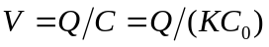
without the dielectric: 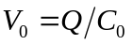
b)
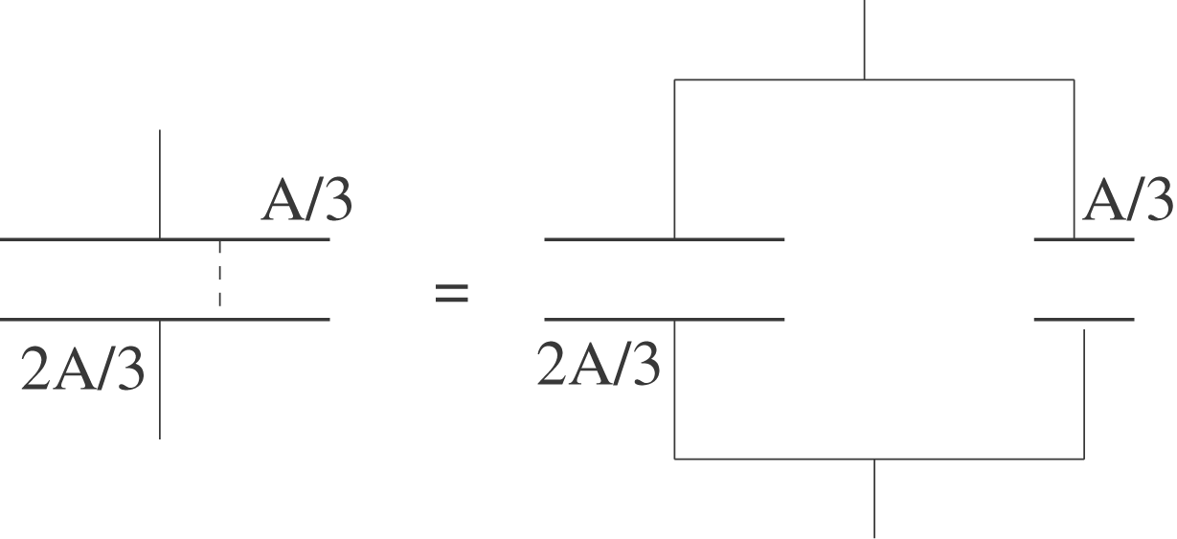
Let 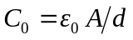 be the capacitance with only air between the plates. With the dielectric filling one-third of the space between the plates, the capacitor is equivalent to 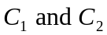 in parallel, where
